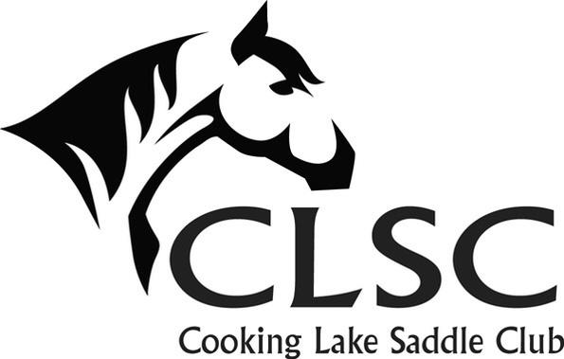
2024 Horse Show & Gymkhana Series
Rules and Regulations

- EQUESTRIAN CANADA rules are guidelines. The judge's decision is final.

- CROSS ENTRY RULES
  - The same rider cannot ride the same horse in walk/trot and loping classes.
  - Two riders may not share the same horse unless one rider is walk/trot and one is in the loping classes OR one rider English and one rider Western.
  - Riders may enter multiple horses, but registration fees are charged for each horse/rider combo. Separate numbers will be issued. Points will be accumulated based on the horse/rider combination, not just the rider.
  - A horse/rider combo that competes in a loping class at a CLSC show cannot participate in a walk/trot class at any future CLSC show.

- REFUNDS: No refunds are available unless the show is canceled by CLSC. You do not need to pre-pay to pre-register. If you are sending an e transfer, please hold off on payment until the day before in case of cancellation due to weather.

- SHOW CLOTHES: Show clothes are not required. Boots must have heels, shirts need sleeves and pants must be appropriate for riding. Tack and clothing must be safe. ASTM/SEI approved helmets are recommended for all riders but are mandatory for all riders under 18 while mounted.

- TACK RULES: Saddles and bridles should be appropriate to the discipline. Australian stock saddles are permitted in western classes. Bosals or any legal bit can be used on any age of horse. Western leverage bits are permitted in western classes only and must have a curb strap or western curb chain. Two hands may be used on leverage bits in western classes. Western headstalls must not have a noseband. Snaffle bits on western headstalls must have a leather chin strap. English leverage bits, kimberwicks and pelhams, are permitted in English classes only and must have a curb strap or English curb chain. A crop no longer than 30cm will be permitted in the english classes only. NO TRAINING AIDS such as martingales or draw reins will be permitted on the grounds. No flashes or drop nosebands. Gag bits, tie downs and protective leg equipment are permissible in gymkhana classes only.

- CLSC MEMBERSHIPS: No memberships will be sold the day of the show. CLSC members get reduced show rates and qualify for year end high point awards.

- AEF memberships are required for all participants. This includes leadliners and handlers.

- NUMBERS: A reusable number will be provided to each horse/rider combo and is to be returned at the end of the show. If showing more than one horse, it is the exhibitor's responsibility to ensure the correct number is worn when being judged.

- LEADLINE: Handlers must be 14 years of age or older. Halters are to be worn underneath bridles.

- TRAIL: Trail will be run on the grass beside the outdoor arena, concurrently with the gymkhana classes. No practicing of obstacles.

- EQUITATION CLASSES: Will not have patterns but the judge may ask for halt, back up, side pass, dropping stirrups, extension, collection or other appropriate skills.
Special note: Walk = 4 beats, trot = 2 beats, canter = 3 beats. Anything other than this and the horse is considered to not be performing the gait and should be judged appropriately.

- STALLIONS: Handlers must be 18 years of age or older.

- RIBBONS: Ribbons will be awarded for 1st-6th place. CLSC will ‘buy back’ any unwanted rosette ribbons for $1.

- HIGH POINT: High point and reserve high point will be awarded for both Performance and Gymkhana at each show. CLSC members will have the option of claiming their prize the day of or “banking” points to go towards a larger year end award.

- YEAR END AWARDS: Year end high point, reserve high point and top three will be available to CLSC members. To qualify you must attend a minimum of one CLSC meeting during 2024 or gather $150 in sponsorship prior to the end of CLSC show season.

- Water is available. Bring your own bucket and feed. Please clean up after your horse, this includes at the trailer and anywhere else on the show grounds.

- Safety is CLSC’s main concern at horse shows. The show judge, any two executive members and/or ring official, have the right to excuse participation to those demonstrating unsafe or inhumane behaviors prior, during or after any equine function (eg. reckless riding in the staging area, playing on trail obstacles). Any two executive members have the right to request non-riders (parents and/or children) to cease unsafe practices in the vicinity of the horse show.

- The executive and judge have the right to refuse any entry.

- Abuse of horses will NOT be tolerated.

- On the show grounds: a) Dogs must be on leashes; b) Children must be supervised; c) no running on bleachers or by arena fences; d) no climbing on arena fence; e) Riders may only walk in the trailer area, no galloping in the field, no horses in the concession or bleacher areas.

